Project Design Phase-II
Data Flow Diagram & User Stories

Date | 31 January 2025
Team ID
Project Name
Maximum Marks | 4 Marks

Data Flow Diagrams:
A Data Flow Diagram (DFD) is a traditional visual representation of the information flows within a system. A neat and clear DFD can depict the right amount of the system requirement graphically. It shows how data enters and leaves the system, what changes the information, and where data is stored.

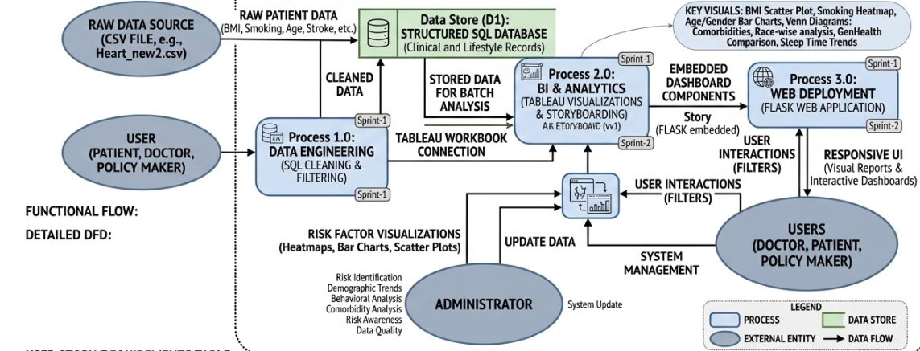

User Stories
User Type | Functional Requirement (Epic) | User Story Number | User Story / Task | Acceptance criteria | Priority | Release
Customer (Mobile user) | Dashboard | USN-1 | As a mobile user, I want the website to automatically shrink and fit my phone screen so I don't have to zoom in to see the charts. | The charts automatically resize themselves when opened on a phone. | High | Sprint-2
Customer (Web user) | Health Analytics | USN-2 | As a patient, I want to look at a chart comparing body weight (BMI), age, and heart disease so I can figure out my personal risk. | There is a working chart where the user can click buttons to filter by their age and weight. | High | Sprint-1
Customer (Web user) | Behavioral Insight | USN-3 | As a patient, I want to see a chart comparing smokers to non-smokers so I can see how bad smoking is for the heart. | A bar chart clearly shows the percentage of heart disease in smokers vs. non-smokers. | Medium | Sprint-1
Healthcare Provider | Risk Assessment | USN-4 | As a doctor, I want to see which age groups and genders get heart disease the most, so I know who is at the highest risk. | The dashboard has charts that clearly split the patients by men/women and age brackets. | High | Sprint-1
Healthcare Provider | Comorbidity Analysis | USN-5 | As a doctor, I want to see if my patients with diabetes or stroke are also getting heart disease, so I can treat all their problems together. | There is a visual showing the overlap of patients who have multiple diseases at once. | High | Sprint-2
Administrator | Data Cleaning (SQL) | USN-6 | As the IT admin, I need to clean the messy spreadsheet data using a database (SQL) before I try to make charts out of it.. | The data is saved in the database with zero blank or broken records. | High | Sprint-1
Administrator | Web Deployment (Flask) | USN-7 | As the IT admin, I want to put the Tableau charts onto a real webpage (using Flask) so people don't have to download special software to see them. | The dashboard successfully loads on a normal internet browser. | Medium | Sprint-2

